Sentiment Analysis – Project report

Author:Brindha Devi
Project Type: Individual Project
Git Repo Link: https://github.com/brindhasp/CodeAlpha_Sentiment-Analysis

EXECUTIVE SUMMARY:
The Sentiment Analysis and Visualization Project is a Python-based text analytics system developed to analyze the emotional tone of quotes extracted from a public dataset. The project focuses on identifying whether a quote expresses positive, negative, or neutral sentiment using Natural Language Processing (NLP) techniques.
Using Python libraries such as Pandas, TextBlob, and Matplotlib, the dataset is processed to compute sentiment polarity scores and categorize each quote accordingly. The results are visualized using graphical representations to better understand the overall emotional distribution of the dataset.
This project demonstrates how textual data can be transformed into structured emotional insights and highlights the importance of sentiment analysis in modern data analytics and decision-making systems.

PROJECT OVERVIEW:

Objective:
To perform Sentiment Analysis on a quotes dataset and generate meaningful emotional insights using Python NLP and visualization libraries.

Scope:
• Load and analyze structured CSV dataset
• Apply sentiment polarity scoring using TextBlob
• Classify quotes into Positive, Negative, or Neutral
• Visualize sentiment distribution using pie charts
• Prepare dataset for advanced NLP or machine learning tasks
Key Features

1. Dataset Loading and Inspection
The dataset is loaded using Pandas and examined to ensure proper structure and data integrity.
2. Sentiment Polarity Calculation
TextBlob is used to calculate the polarity score of each quote.
- Polarity > 0 → Positive
- Polarity < 0 → Negative
- Polarity = 0 → Neutral

3. Sentiment Classification

A new feature column called Sentiment is created in the dataset to categorize each quote based on emotional tone.

4. Pie Chart Visualization

Matplotlib is used to generate a pie chart that visually represents the percentage distribution of sentiments.

5. Clean Structured Output

The final dataset includes sentiment labels and is ready for further NLP processing or machine learning applications.

6. NLP-Ready Framework
The project establishes a basic Natural Language Processing pipeline that can be extended to real-world applications like review analysis, social media monitoring, and opinion mining.

TECHNICAL IMPLEMENTATION:

Technology Stack:

• Programming Language: Python
• Data Analysis Library: Pandas
• NLP Library: TextBlob
• Data Visualization: Matplotlib
• Development Environment: VS Code / Jupyter Notebook
• Dataset Source: quotes_data.csv

ANALYSIS PERFORMED:

1.Dataset Structure Analysis
- Total Entries: 10
- Columns: Quote, Author, Tags
- Data Type: String
- No missing values found

2. Sentiment Distribution Analysis
Each quote is analyzed using TextBlob’s sentiment polarity feature.
Based on polarity scores:
- Positive quotes express motivation, optimism, or happiness.
- Negative quotes express sadness or critical tone.
- Neutral quotes contain balanced or factual statements.
The pie chart visualization displays the percentage distribution of each sentiment category.

Performance Metrics:
• Accurate sentiment classification using polarity scores
• Correct feature engineering (Sentiment column)
• Clear visual representation of emotional distribution
• Efficient execution with minimal computational overhead

SOURCE CODE IMPLEMENTATION (Screenshot)
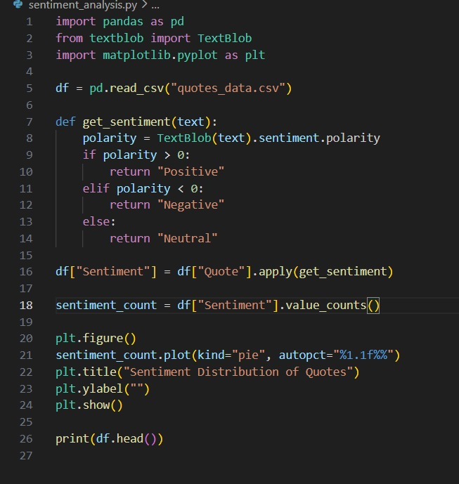

Extracted Job Result:

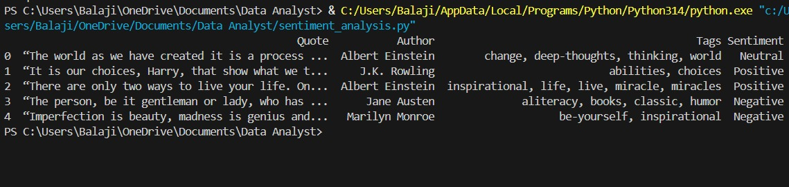

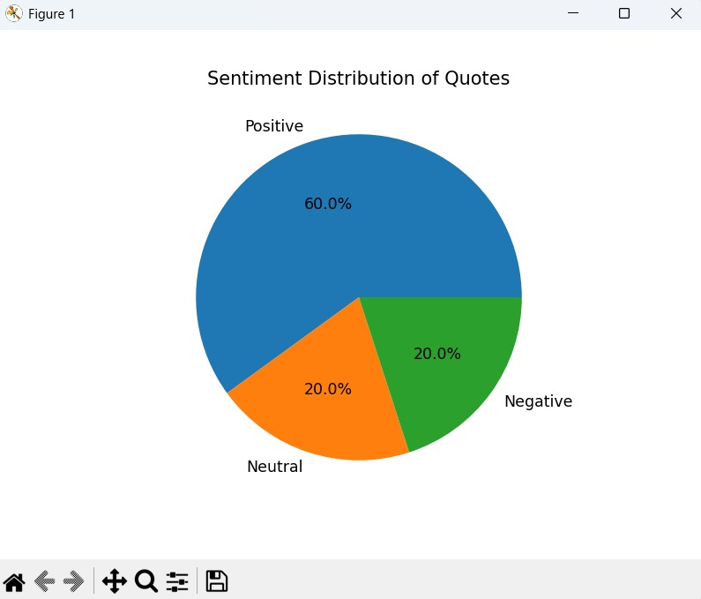

CONSTRAINTS:

• Small dataset size (10 records)
• TextBlob provides rule-based sentiment (not deep learning based)
• Limited emotional granularity (only 3 classes)
• Static dataset (no real-time streaming data)

PROJECT IMPACT AND VALUE:

Immediate Benefits
• Practical understanding of NLP basics
• Hands-on experience with sentiment analysis
• Strengthens Python text analytics skills
• Demonstrates data visualization for emotional insights

Long-Term Potential
• Integration with real-time Twitter or review scraping
• Advanced NLP using NLTK, SpaCy, or Transformers
• Sentiment-based recommendation systems
• Business review analytics
• Customer feedback monitoring system
• Machine learning model training for text classification

CONCLUSION

The Sentiment Analysis and Visualization project successfully demonstrates how textual datasets can be processed to extract emotional insights using Python. By leveraging Pandas for data manipulation, TextBlob for sentiment scoring, and Matplotlib for visualization, meaningful emotional patterns were identified within the dataset.

